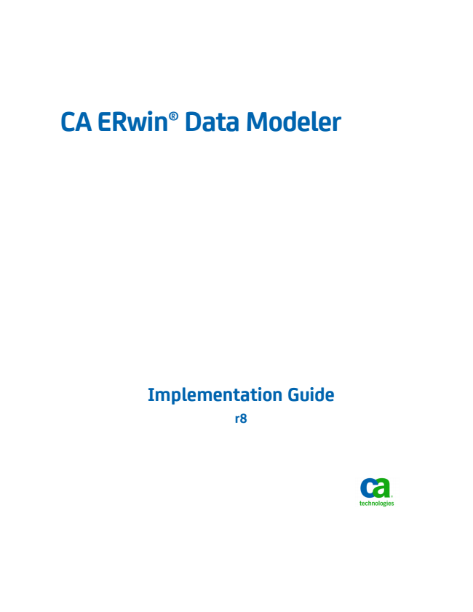

**CA ERwin® Data Modeler**

**Implementation Guide r8**

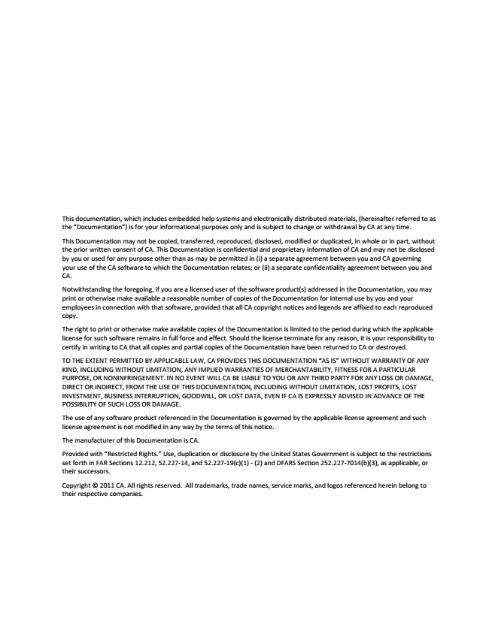

This documentation, which includes embedded help systems and electronically distributed materials, (hereinafter referred to as the “Documentation”) is for your informational purposes only and is subject to change or withdrawal by CA at any time.

This Documentation may not be copied, transferred, reproduced, disclosed, modified or duplicated, in whole or in part, without the prior written consent of CA. This Documentation is confidential and proprietary information of CA and may not be disclosed by you or used for any purpose other than as may be permitted in (i) a separate agreement between you and CA governing your use of the CA software to which the Documentation relates; or (ii) a separate confidentiality agreement between you and CA.

Notwithstanding the foregoing, if you are a licensed user of the software product(s) addressed in the Documentation, you may print or otherwise make available a reasonable number of copies of the Documentation for internal use by you and your employees in connection with that software, provided that all CA copyright notices and legends are affixed to each reproduced copy.

The right to print or otherwise make available copies of the Documentation is limited to the period during which the applicable license for such software remains in full force and effect. Should the license terminate for any reason, it is your responsibility to certify in writing to CA that all copies and partial copies of the Documentation have been returned to CA or destroyed.

TO THE EXTENT PERMITTED BY APPLICABLE LAW, CA PROVIDES THIS DOCUMENTATION “AS IS” WITHOUT WARRANTY OF ANY KIND, INCLUDING WITHOUT LIMITATION, ANY IMPLIED WARRANTIES OF MERCHANTABILITY, FITNESS FOR A PARTICULAR PURPOSE, OR NONINFRINGEMENT. IN NO EVENT WILL CA BE LIABLE TO YOU OR ANY THIRD PARTY FOR ANY LOSS OR DAMAGE, DIRECT OR INDIRECT, FROM THE USE OF THIS DOCUMENTATION, INCLUDING WITHOUT LIMITATION, LOST PROFITS, LOST INVESTMENT, BUSINESS INTERRUPTION, GOODWILL, OR LOST DATA, EVEN IF CA IS EXPRESSLY ADVISED IN ADVANCE OF THE POSSIBILITY OF SUCH LOSS OR DAMAGE.

The use of any software product referenced in the Documentation is governed by the applicable license agreement and such license agreement is not modified in any way by the terms of this notice.

The manufacturer of this Documentation is CA.

Provided with “Restricted Rights.” Use, duplication or disclosure by the United States Government is subject to the restrictions set forth in FAR Sections 12.212, 52.227-14, and 52.227-19(c)(1) - (2) and DFARS Section 252.227-7014(b)(3), as applicable, or their successors.

Copyright © 2011 CA. All rights reserved. All trademarks, trade names, service marks, and logos referenced herein belong to their respective companies.

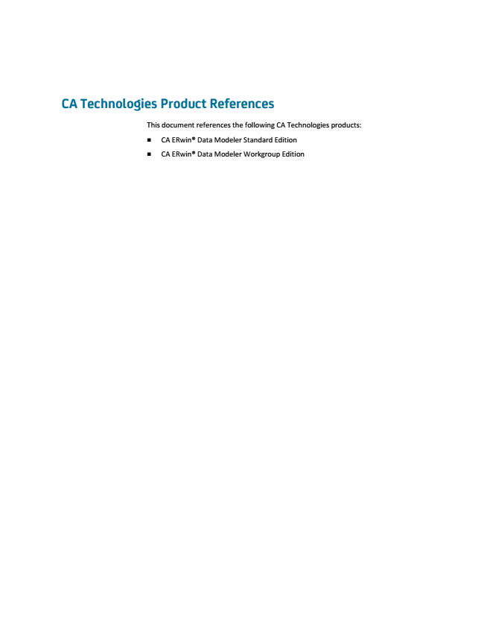

**CA Technologies Product References**

This document references the following CA Technologies products:

■ CA ERwin® Data Modeler Standard Edition

■ CA ERwin® Data Modeler Workgroup Edition

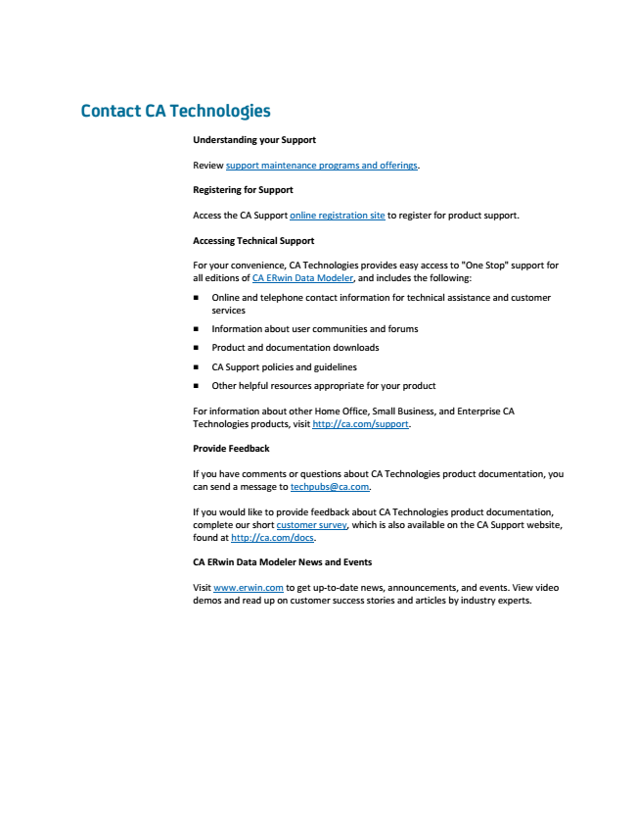

**Contact CA Technologies**

**Understanding your Support**

Review support maintenance programs and offerings.

**Registering for Support**

Access the CA Support online registration site to register for product support.

**Accessing Technical Support**

For your convenience, CA Technologies provides easy access to "One Stop" support for all editions of CA ERwin Data Modeler, and includes the following:

■ Online and telephone contact information for technical assistance and customer services

■ Information about user communities and forums

■ Product and documentation downloads

■ CA Support policies and guidelines

■ Other helpful resources appropriate for your product

For information about other Home Office, Small Business, and Enterprise CA Technologies products, visit http://ca.com/support.

**Provide Feedback**

If you have comments or questions about CA Technologies product documentation, you can send a message to techpubs@ca.com.

If you would like to provide feedback about CA Technologies product documentation, complete our short customer survey, which is also available on the CA Support website, found at http://ca.com/docs.

**CA ERwin Data Modeler News and Events**

Visit www.erwin.com to get up-to-date news, announcements, and events. View video demos and read up on customer success stories and articles by industry experts.

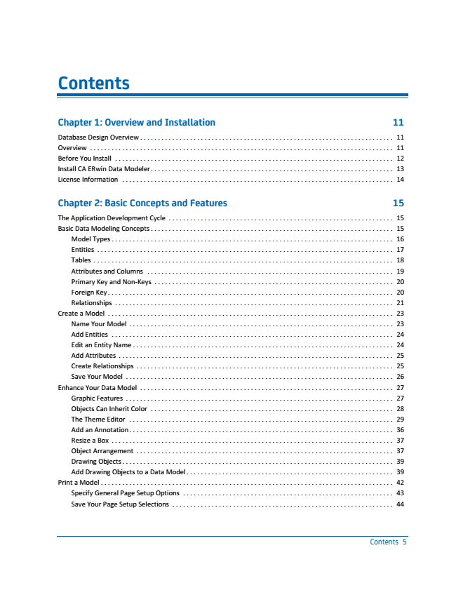

**Contents**

**Chapter 1: Overview and Installation 11**

Database Design Overview ....................................................................... 11 Overview

.....................................................................................

11 Before You Install

..............................................................................

12 Install CA ERwin Data Modeler .................................................................... 13 License Information ............................................................................ 14

**Chapter 2: Basic Concepts and Features 15**

The Application Development Cycle ............................................................... 15 Basic Data Modeling Concepts .................................................................... 15

Model Types

...............................................................................

16 Entities

...................................................................................

17 Tables .................................................................................... 18 Attributes and Columns ..................................................................... 19 Primary Key and Non-Keys

...................................................................

20 Foreign Key

................................................................................

20 Relationships

..............................................................................

21 Create a Model ................................................................................ 23 Name Your Model .......................................................................... 23 Add Entities

...............................................................................

24 Edit an Entity Name

.........................................................................

24 Add Attributes

.............................................................................

25 Create Relationships ........................................................................ 25 Save Your Model ........................................................................... 26 Enhance Your Data Model

.......................................................................

27 Graphic Features

...........................................................................

27 Objects Can Inherit Color .................................................................... 28 The Theme Editor .......................................................................... 29 Add an Annotation .......................................................................... 36 Resize a Box

...............................................................................

37 Object Arrangement

........................................................................

37 Drawing Objects ............................................................................ 39 Add Drawing Objects to a Data Model .......................................................... 39 Print a Model .................................................................................. 42

Specify General Page Setup Options

...........................................................

43 Save Your Page Setup Selections

..............................................................

44

Contents 5

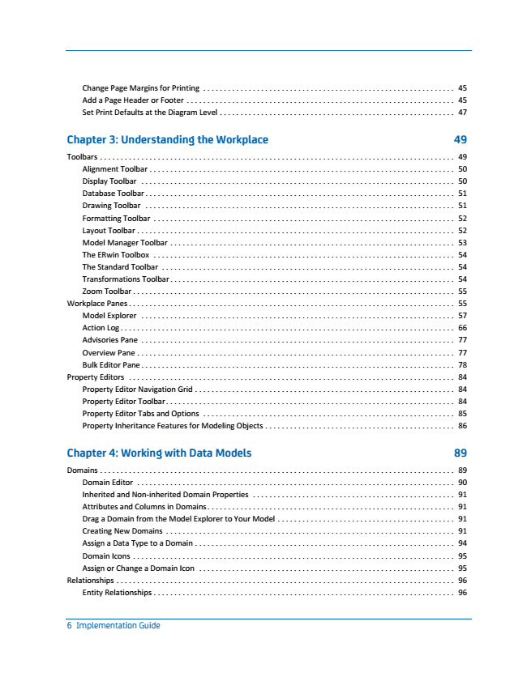

45 Change Page Margins for Printing

............................................................. Add a Page Header or Footer ................................................................. 45 Set Print Defaults at the Diagram Level ......................................................... 47

**Chapter 3: Understanding the Workplace 49**

Toolbars ...................................................................................... 49 Alignment Toolbar .......................................................................... 50 Display Toolbar

............................................................................

50 Database Toolbar

...........................................................................

51 Drawing Toolbar ........................................................................... 51 Formatting Toolbar ......................................................................... 52 Layout Toolbar ............................................................................. 52 Model Manager Toolbar

.....................................................................

53 The ERwin Toolbox

.........................................................................

54 The Standard Toolbar ....................................................................... 54 Transformations Toolbar ..................................................................... 54 Zoom Toolbar

..............................................................................

55 Workplace Panes

...............................................................................

55 Model Explorer

............................................................................

57 Action Log ................................................................................. 66 Advisories Pane ............................................................................ 77 Overview Pane

.............................................................................

77 Bulk Editor Pane

............................................................................

78 Property Editors

...............................................................................

84 Property Editor Navigation Grid ............................................................... 84 Property Editor Toolbar ...................................................................... 84 Property Editor Tabs and Options

.............................................................

85 Property Inheritance Features for Modeling Objects

..............................................

86

**Chapter 4: Working with Data Models 89**

Domains

......................................................................................

89 Domain Editor ............................................................................. 90 Inherited and Non-inherited Domain Properties ................................................. 91 Attributes and Columns in Domains ............................................................ 91 Drag a Domain from the Model Explorer to Your Model

...........................................

91 Creating New Domains

......................................................................

91 Assign a Data Type to a Domain ............................................................... 94 Domain Icons .............................................................................. 95 Assign or Change a Domain Icon

..............................................................

95 Relationships

..................................................................................

96 Entity Relationships

.........................................................................

96

6 Implementation Guide

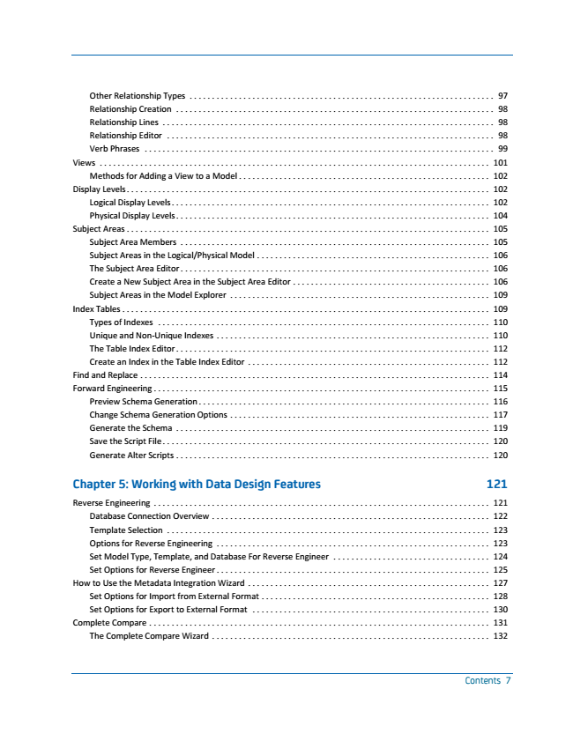

Other Relationship Types

....................................................................

97 Relationship Creation ....................................................................... 98 Relationship Lines .......................................................................... 98 Relationship Editor ......................................................................... 98 Verb Phrases

..............................................................................

99 Views

.......................................................................................

101 Methods for Adding a View to a Model ........................................................ 102 Display Levels................................................................................. 102 Logical Display Levels....................................................................... 102 Physical Display Levels

......................................................................

104 Subject Areas

.................................................................................

105 Subject Area Members ..................................................................... 105 Subject Areas in the Logical/Physical Model .................................................... 106 The Subject Area Editor ..................................................................... 106 Create a New Subject Area in the Subject Area Editor

............................................

106 Subject Areas in the Model Explorer

..........................................................

109 Index Tables .................................................................................. 109 Types of Indexes .......................................................................... 110 Unique and Non-Unique Indexes

.............................................................

110 The Table Index Editor

......................................................................

112 Create an Index in the Table Index Editor

......................................................

112 Find and Replace .............................................................................. 114 Forward Engineering ........................................................................... 115

Preview Schema Generation

.................................................................

116 Change Schema Generation Options

..........................................................

117 Generate the Schema

......................................................................

119 Save the Script File ......................................................................... 120 Generate Alter Scripts ...................................................................... 120

**Chapter 5: Working with Data Design Features 121**

Reverse Engineering ........................................................................... 121

Database Connection Overview

..............................................................

122 Template Selection

........................................................................

123 Options for Reverse Engineering ............................................................. 123 Set Model Type, Template, and Database For Reverse Engineer ................................... 124 Set Options for Reverse Engineer ............................................................. 125 How to Use the Metadata Integration Wizard

......................................................

127 Set Options for Import from External Format

...................................................

128 Set Options for Export to External Format ..................................................... 130 Complete Compare ............................................................................ 131

The Complete Compare Wizard

..............................................................

132

Contents 7

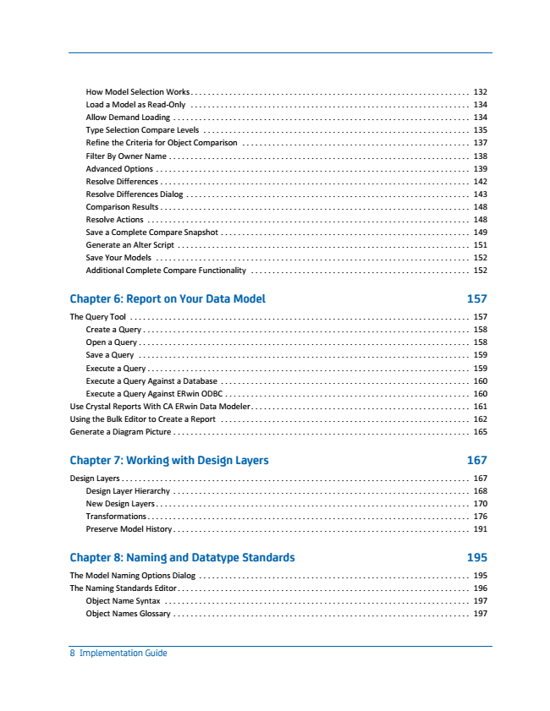

132 How Model Selection Works

................................................................. Load a Model as Read-Only ................................................................. 134 Allow Demand Loading ..................................................................... 134 Type Selection Compare Levels .............................................................. 135 Refine the Criteria for Object Comparison

.....................................................

137 Filter By Owner Name

......................................................................

138 Advanced Options ......................................................................... 139 Resolve Differences ........................................................................ 142 Resolve Differences Dialog .................................................................. 143 Comparison Results

........................................................................

148 Resolve Actions

...........................................................................

148 Save a Complete Compare Snapshot .......................................................... 149 Generate an Alter Script .................................................................... 151 Save Your Models ......................................................................... 152 Additional Complete Compare Functionality

...................................................

152

**Chapter 6: Report on Your Data Model 157**

The Query Tool

...............................................................................

157 Create a Query

............................................................................

158 Open a Query ............................................................................. 158 Save a Query ............................................................................. 159 Execute a Query

...........................................................................

159 Execute a Query Against a Database

..........................................................

160 Execute a Query Against ERwin ODBC

.........................................................

160 Use Crystal Reports With CA ERwin Data Modeler................................................... 161 Using the Bulk Editor to Create a Report .......................................................... 162 Generate a Diagram Picture

.....................................................................

165

**Chapter 7: Working with Design Layers 167**

Design Layers

.................................................................................

167 Design Layer Hierarchy

.....................................................................

168 New Design Layers ......................................................................... 170 Transformations ........................................................................... 176 Preserve Model History ..................................................................... 191

**Chapter 8: Naming and Datatype Standards 195**

The Model Naming Options Dialog

...............................................................

195 The Naming Standards Editor

....................................................................

196 Object Name Syntax

.......................................................................

197 Object Names Glossary ..................................................................... 197

8 Implementation Guide

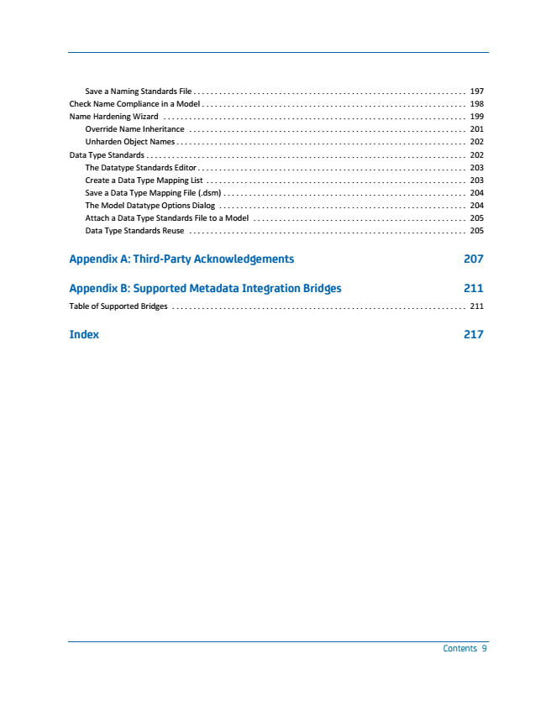

Save a Naming Standards File

................................................................

197 Check Name Compliance in a Model .............................................................. 198 Name Hardening Wizard ....................................................................... 199 Override Name Inheritance ................................................................. 201 Unharden Object Names

....................................................................

202 Data Type Standards

...........................................................................

202 The Datatype Standards Editor ............................................................... 203 Create a Data Type Mapping List ............................................................. 203 Save a Data Type Mapping File (.dsm) ......................................................... 204 The Model Datatype Options Dialog

..........................................................

204 Attach a Data Type Standards File to a Model

..................................................

205 Data Type Standards Reuse ................................................................. 205

**Appendix A: Third-Party Acknowledgements 207**

**Appendix B: Supported Metadata Integration Bridges 211**

Table of Supported Bridges ..................................................................... 211

**Index 217**

Contents 9

